**Langes MMA presents:**

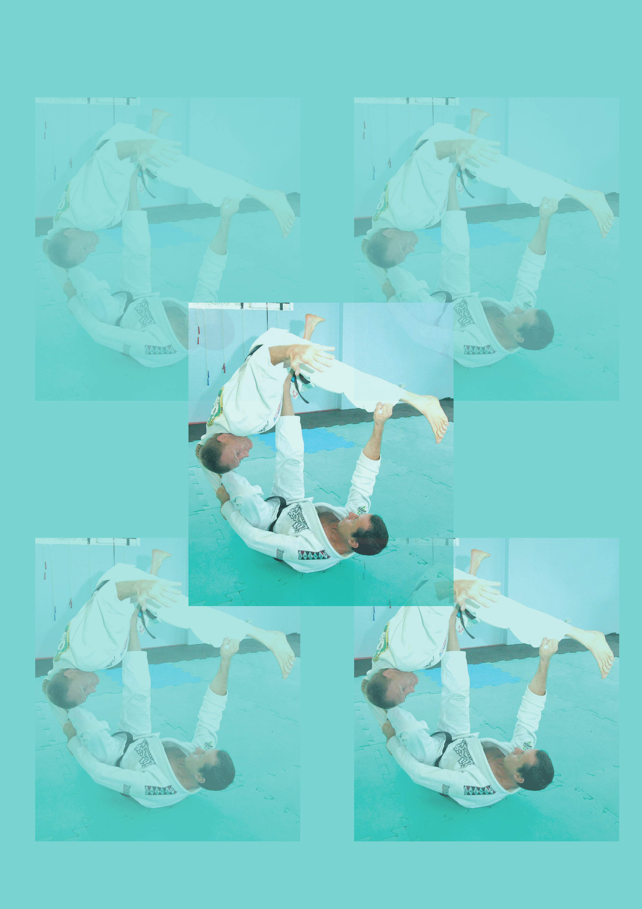

##### Kids Competition Party

**Saturday 24th February 2018**

Where: 7-380 Pittwater Rd North Manly

Time: 5-6 years old 9.30

7-8 years ols 10.30

9-10 years old 10.30

11-12 years old 11.00

13-14 years old 11.30

15-17 years old 12.00pm

Please arrive 20 minutes beforehand

Cost: $40.00 to compete

Trophies / Medals for 1st, 2nd and 3rd

Lolly bags for everyone!

**Fun and safe competition for beginners**